<https://www.c-sharpcorner.com/UploadFile/deveshomar/exporting-datatable-to-excel-in-C-Sharp-using-interop/>

[](https://www.c-sharpcorner.com/technologies/asp-dot-net-programming)

Exporting DataTable to Excel in C# Using Interop

Here in this article we will use a sample datatable and learn how to export data to an Excel file.

* [](https://www.c-sharpcorner.com/members/devesh-omar2)

* [Devesh Omar](https://www.c-sharpcorner.com/members/devesh-omar2)

* Nov 20 2018
* [14](javascript:void(0);)
* [22](javascript:void(0);)
* 621.8k
* [facebook](https://www.facebook.com/sharer.php?u=https://goo.gl/mMmsZL)
* [twitter](https://twitter.com/intent/tweet?&via=CsharpCorner&related=CsharpCorner&text=Exporting+DataTable+to+Excel+in+C%23+Using+Interop%20https://goo.gl/mMmsZL)
* [linkedIn](https://www.linkedin.com/shareArticle?mini=true&url=https://goo.gl/mMmsZL)
* [google Plus](https://plus.google.com/share?url=https://goo.gl/mMmsZL)
* [Reddit](https://www.reddit.com/submit?title=Exporting+DataTable+to+Excel+in+C%23+Using+Interop&url=https%3a%2f%2fwww.c-sharpcorner.com%2fUploadFile%2fdeveshomar%2fexporting-datatable-to-excel-in-C-Sharp-using-interop%2fdefault.aspx)
* [Expand](javascript:void(0);)

[**DatatableToExcel.zip**](javascript:void(0);)

[Download Free .NET & JAVA Files API](https://www.c-sharpcorner.com/AdRedirector.aspx?AdId=133&target=https://www.e-iceblue.com/download/free-products.html?aff_id=100" \t "_blank)

**Introduction**  
I would like to share a utility that can be used to export a datatable to Excel file using C#.  
  
We have various approaches to perform this activity.  
  
In ASP.NET we can do this by changing the Content type to xls but in C# .Net we might have various other approaches.  
  
Through this article we will learn how to export a data table to Excel using Interop.  
  
**Code and Steps**  
Here in this application we will use a Sample datatable and then learn how to export data to an Excel file.  
  
We will learn the following things in this article:

1. Creating Excel file using C#
2. Writing data to cells
3. Formatting data to cells
4. Working with Excel range

**1. Adding References**

First we need to add a reference for Microsoft.office.interop.Excel as in the following:

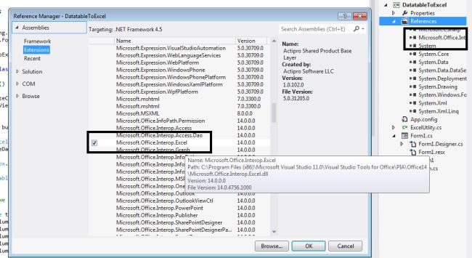  
  
**2. Adding sample data table to the code**

Use the following code to add the sample data table:

1. **static** DataTable GetTable()
2. {
3. //
4. // Here we create a DataTable with four columns.
5. //
6. DataTable table = **new** DataTable();
7. table.Columns.Add("ID", **typeof**(**int**));
8. table.Columns.Add("Name", **typeof**(**string**));
9. table.Columns.Add("Sex", **typeof**(**string**));
10. table.Columns.Add("CreatedDate", **typeof**(**string**));
11. table.Columns.Add("City", **typeof**(**string**));
12. //
13. // Here we add five DataRows.
14. //
15. table.Rows.Add(25, "Devesh Omar", "M", DateTime.Now, "Noida");
16. table.Rows.Add(50, "Nikhil Vats", "M", DateTime.Now, "Noida");
17. table.Rows.Add(10, "Heena Sharma", "F", DateTime.Now, "Delhi");
18. table.Rows.Add(21, "Nancy Sharma", "F", DateTime.Now, "Delhi");
19. table.Rows.Add(100, "Avinash", "M", DateTime.Now, "Delhi");
20. table.Rows.Add(25, "Devesh gupta", "M", DateTime.Now, "Delhi");
21. table.Rows.Add(50, "Nikhil gupta", "M", DateTime.Now, "Noida");
22. table.Rows.Add(10, "HS gupta", "F", DateTime.Now, "Delhi");
23. table.Rows.Add(21, "VS gupta", "F", DateTime.Now, "Delhi");
24. table.Rows.Add(100, "RJ gupta", "M", DateTime.Now, "Delhi");
25. **return** table;
26. }

**3. Class file for generating Excel**

We created a separate class file for generating the Excel (Excelutlity.cs).  
  
**4. Creation of Excel objects**

Define the following variables:

1. Microsoft.Office.Interop.Excel.Application excel;
2. Microsoft.Office.Interop.Excel.Workbook excelworkBook;
3. Microsoft.Office.Interop.Excel.Worksheet excelSheet;
4. Microsoft.Office.Interop.Excel.Range excelCellrange;

I have attached sample code for more details.  
  
**5. Initialization of Excel objects**

1. // Start Excel and get Application object.
2. excel = **new** Microsoft.Office.Interop.Excel.Application();
3. // for making Excel visible
4. excel.Visible = **false**;
5. excel.DisplayAlerts = **false**;
6. // Creation a new Workbook
7. excelworkBook = excel.Workbooks.Add(Type.Missing);
8. // Workk sheet
9. excelSheet = (Microsoft.Office.Interop.Excel.Worksheet)excelworkBook.ActiveSheet;
10. excelSheet.Name = "Test work sheet";

**6. Writing to Excel file**

1. excelSheet.Cells[1, 1] = “Sample test data”;
2. excelSheet.Cells[1, 2] = "Date : " + DateTime.Now.ToShortDateString();

**7. Working with range and formatting Excel cells**

1. // now we resize the columns
2. excelCellrange = excelSheet.Range[excelSheet.Cells[1, 1], excelSheet.Cells[rowcount, dataTable.Columns.Count]];
3. excelCellrange.EntireColumn.AutoFit();
4. Microsoft.Office.Interop.Excel.Borders border = excelCellrange.Borders;
5. border.LineStyle = Microsoft.Office.Interop.Excel.XlLineStyle.xlContinuous;
6. border.Weight = 2d;

**8. Coloring the cells**

We will use the following function to format and color Excel cells:

1. **public** **void** FormattingExcelCells(Microsoft.Office.Interop.Excel.Range range, **string** HTMLcolorCode, System.Drawing.Color fontColor, **bool** IsFontbool)
2. {
3. range.Interior.Color = System.Drawing.ColorTranslator.FromHtml(HTMLcolorCode);
4. range.Font.Color = System.Drawing.ColorTranslator.ToOle(fontColor);
5. **if** (IsFontbool == **true**)
6. {
7. range.Font.Bold = IsFontbool;
8. }
9. }

**9.** Running the application

We are binding a DataGrid at the load of a Form.

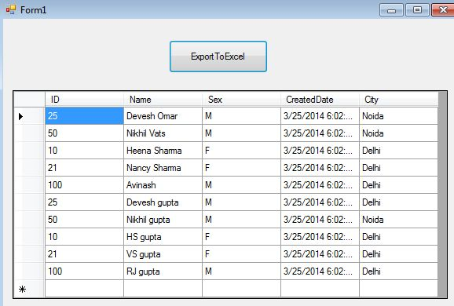  
  
**10.**After clicking on Export to Excel we will have our Excel file as per the following screen. You need to modify the file out path in the attached code.

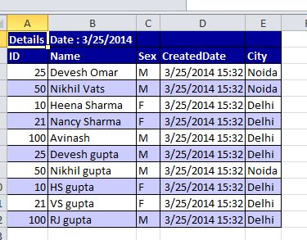  
  
**Conclusion**  
  
The attached application can be used in projects for the Reporting Feature.

* [C#](https://www.c-sharpcorner.com/topics/c-sharp)
* [DataTable to Excel using Interop](https://www.c-sharpcorner.com/topics/datatable-to-excel-using-interop)
* [Exporting DataTable to Excel](https://www.c-sharpcorner.com/topics/exporting-datatable-to-excel)
* [Interop](https://www.c-sharpcorner.com/topics/interop)

[](https://www.c-sharpcorner.com/members/devesh-omar2)

[Devesh Omar](https://www.c-sharpcorner.com/members/devesh-omar2)

https://www.c-sharpcorner.com/images/top_500.png

I am Software Developer and have worked with various MNC's in Noida. http://compilefactory.blogspot.in/

<https://www.c-sharpcorner.com/members/devesh-omar2>

* [**291**](https://www.c-sharpcorner.com/top-members)
* [**4.8m**](https://www.c-sharpcorner.com/members/devesh-omar2/top-articles)
* [**2**](https://www.c-sharpcorner.com/members/mvps/)

Don’t miss Devesh Omar’s next article

[](https://www.c-sharpcorner.com/members/devesh-omar2)

[Devesh Omar](https://www.c-sharpcorner.com/members/devesh-omar2)

**291 5.9k 4.8m**

+ Follow

[View Previous Comments](javascript:void(0);)

* [**14**](javascript:void(0);)

* [**22**](javascript:void(0);)

https://csharpcorner-mindcrackerinc.netdna-ssl.com/UploadFile/AuthorImage/DefaultAuthorImage.jpg.ashx?width=56&height=56



[Dharmendra Kumar](https://www.c-sharpcorner.com/members/dharmendra-kumar58)

Thank you very much for this article.

Feb 06, 2019[Dharmendra Kumar](https://www.c-sharpcorner.com/members/dharmendra-kumar58)

**1357 411 1.7k**

* [0](javascript:void(0))

* [0](javascript:void(0))
* [Reply](javascript:void(0))

[Mujeeb Mohammed](https://www.c-sharpcorner.com/members/mujeeb-mohammed3)

How can I make the first line merge all the cells and appear as a single cell?

Sep 19, 2018[Mujeeb Mohammed](https://www.c-sharpcorner.com/members/mujeeb-mohammed3)

**1693 73 958**

* [0](javascript:void(0))

* [0](javascript:void(0))
* [Reply](javascript:void(0))

[Yogi S](https://www.c-sharpcorner.com/members/boby-arrora)

Hi Devesh , this helped alot , thank u so much !!

Sep 18, 2018[Yogi S](https://www.c-sharpcorner.com/members/boby-arrora)

**1737 29 0**

* [0](javascript:void(0))

* [0](javascript:void(0))
* [Reply](javascript:void(0))

[Abhishek Singh](https://www.c-sharpcorner.com/members/abhishek-singh248)

Hi It works fine for me but is there any way I can get the excel as a downloadable file. This approach silently adds a file in the desired location. Users won't realize till they reach that directory. Requirement is when users clicks on Export, a file should be returned instead of SaveAs() operation that is being performed.

Mar 16, 2018[Abhishek Singh](https://www.c-sharpcorner.com/members/abhishek-singh248)